How to Build the LEGO Crane
Twelve steps, from the baseplate upward
These steps are a reconstruction, not a record. They were read off photographs of the finished bird, so the piece sizes are one plausible way to reach that shape rather than the exact pieces that were used. Two places are reasoned rather than seen, and say so where they come up: the rectangular bricks inside the body, which the wings hide, and the legs, which are hard to photograph in black. Substitute freely for whatever is in the bin — choosing the substitute is the design work, not a compromise.
Table 1. Every piece used, gathered by the part it builds.
Part | Color | Pieces
Baseplate | Green | 1 baseplate, 16 × 8
Legs | Black | 2 plates 1 × 1; 2 columns 1 × 1 × 2;  2 plates 1 × 1
Body core | White | 1 brick 2 × 8; 1 brick 2 × 7
Wings | White, Light Gray | 2 wedges; 2 blades 1 × 2;  2 blades 2 × 2
Tail | Black, Light Gray | 2 slopes, 2 × 1
Body top | White, Light Gray | 1 brick 2 × 2; 1 brick 2 × 3;  1 ridged plate; 2 slopes 2 × 2
Neck | Light Gray | 1 brick 1 × 2 (seat);  1 column 1 × 1 × 4
Head | Black | 1 brick 2 × 2; 1 plate 2 × 3
Eye | White | 1 round tile, 1 × 1
Beak | Red | 1 slope, 2 × 2
Crown | Yellow | 2 inverted slopes; 1 cone

Step 1. Start with the baseplate
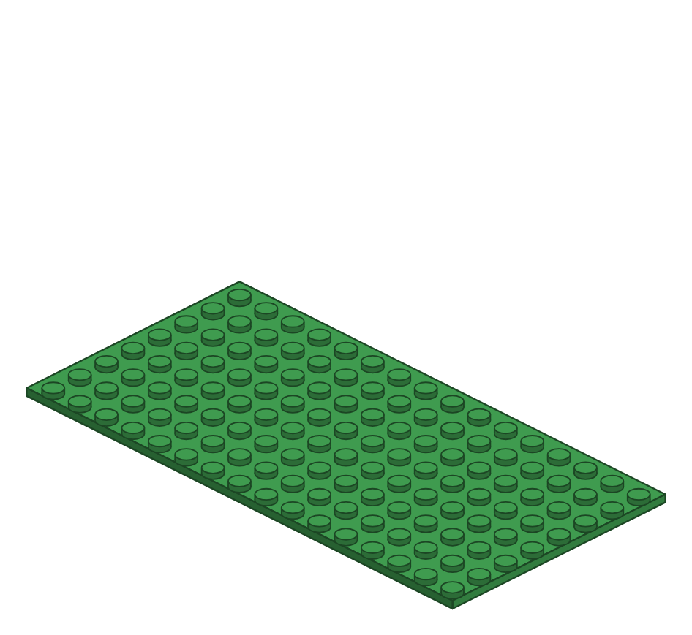
One green baseplate, 16 × 8. Set it down with the long side facing you — the crane will face to the right, and will very nearly fill it.
Add these pieces: 1 green baseplate, 16 × 8
Step 2. Stand up the two legs
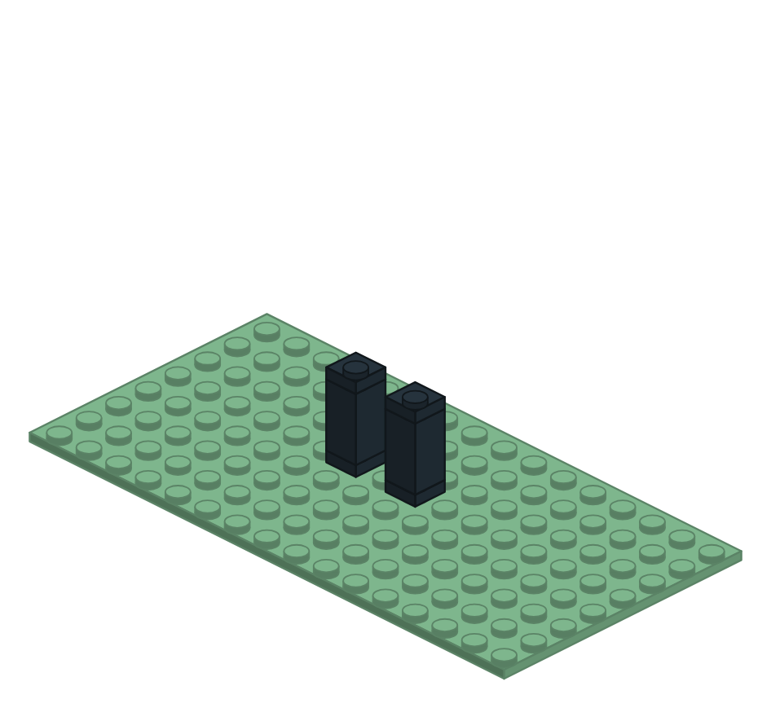
Three pieces each: a short one on the baseplate, a long one for the span, a short one on top. The long piece reaches and the short ones join, which is where the strength is. Least certain step in the sheet — black photographs badly, and this is read from a dark picture.
Add these pieces: 2 black 1 × 1 plates (feet); 2 black 1 × 1 columns; 2 black 1 × 1 plates (tops)
Step 3. Lay the body's rectangular core
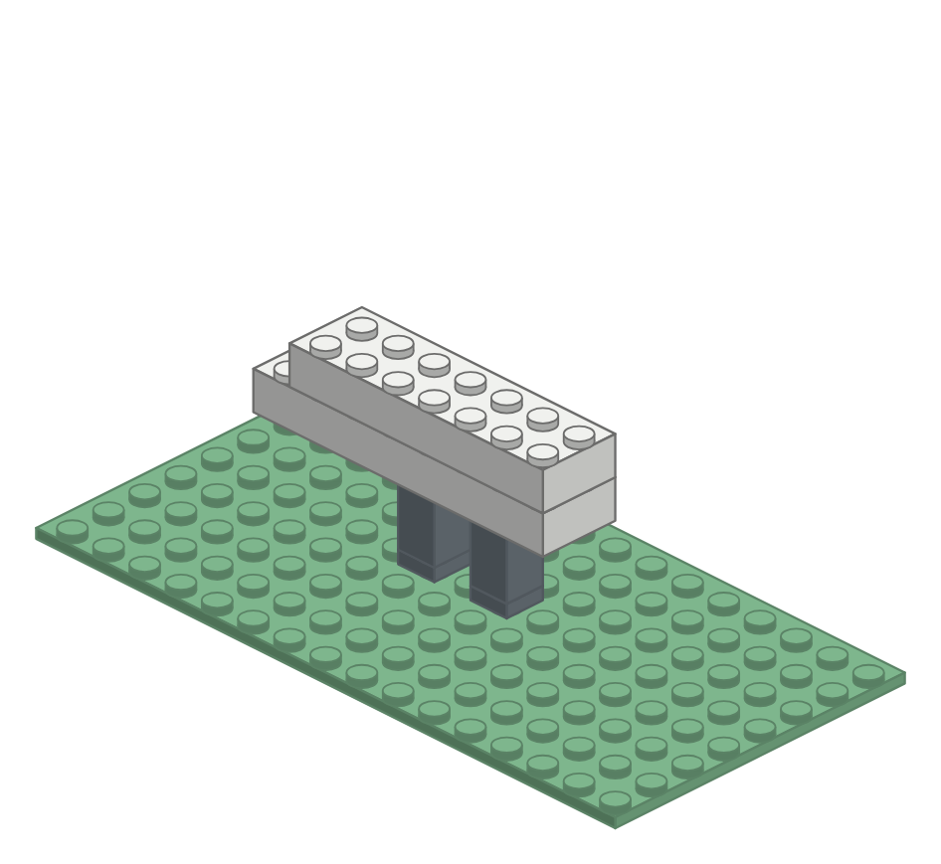
Two plain courses of rectangular brick. Almost none of this will show once the wings go on — it is the thing everything else mounts to. Inferred: the wings hide these bricks in every photograph, but a strip of the body's top edge is visible above the wing, so their size is read from the outline rather than guessed.
Add these pieces: 1 white 2 × 8 brick; 1 white 2 × 7 brick
Step 4. Mount the wings on the core
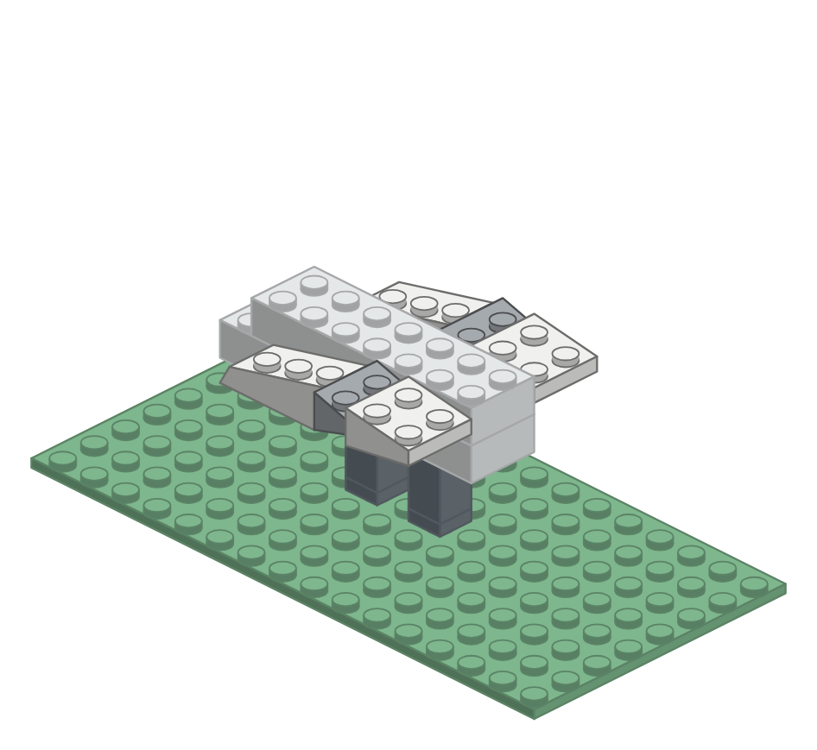
Three pieces a side, flanking the core at the same height so they hide it. The back is a wedge — tilted on top and drawn in at the sides at once — and the two pieces in front of it thin toward the leading edge because their tops and undersides both slope away. Three pieces carry nearly all of the bird's curve.
Add these pieces: 2 white wedges; 2 light gray 1 × 2 blades; 2 white 2 × 2 blades
Step 5. Taper the tail
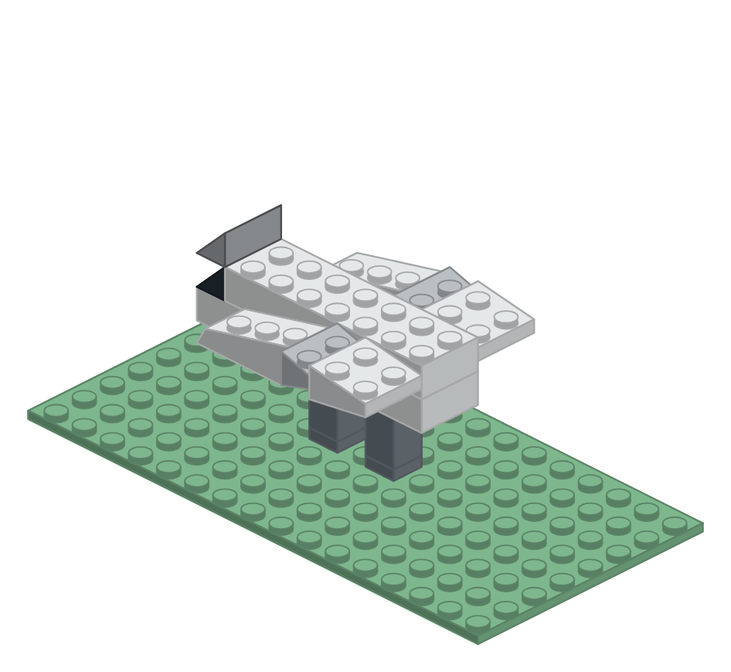
Two slopes stacked at the very back, so the tail draws down across two courses and comes to a fine point rather than a chopped corner. The lower one is black — expedience, not design: it is what the bin had.
Add these pieces: 1 black 2 × 1 slope; 1 light gray 2 × 1 slope
Step 6. Close the top of the body
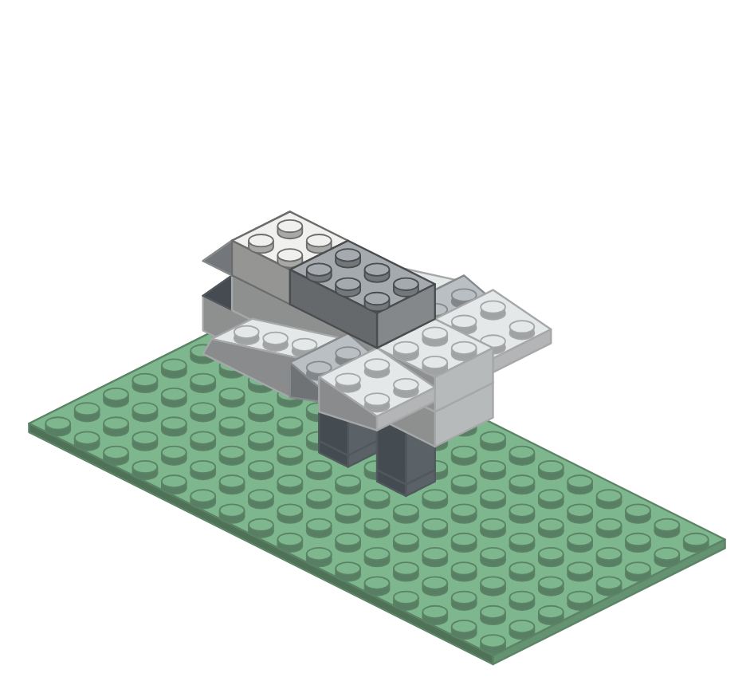
A white brick behind and a gray one in front of it. Neither is shaped: they are the course the shaped pieces sit on. Block the mass out square first, then clothe it — that way the bird is a bird at every stage.
Add these pieces: 1 white 2 × 2 brick; 1 light gray 2 × 3 brick
Step 7. Cap the back with a ridged plate
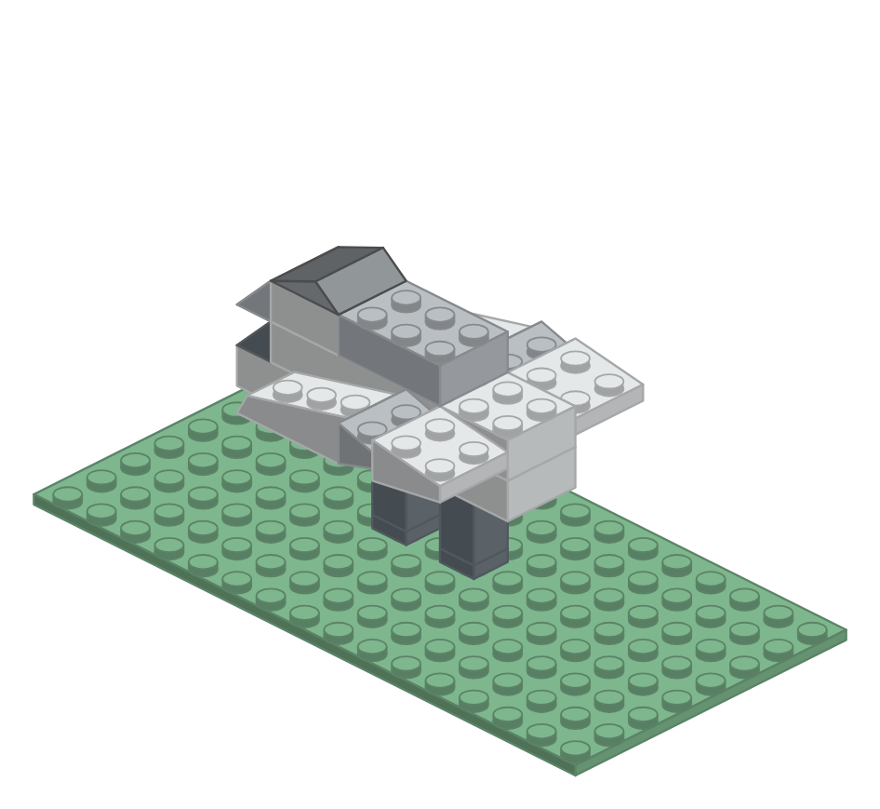
A thin gray plate sloped on top on both sides, like the roof of a house — but asymmetrical, the left face longer than the right. One odd piece does more for the back than three ordinary ones would.
Add these pieces: 1 light gray ridged plate
Step 8. Raise the shoulder toward the neck
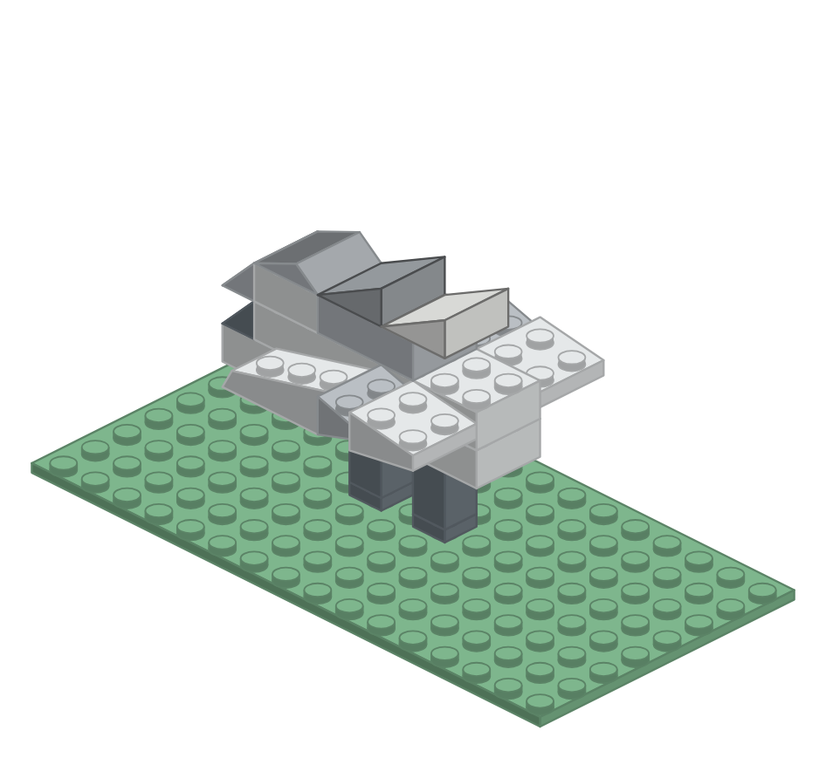
Two slopes resting on the gray brick, stepping the body's line up to meet the neck. One gray, one white — again what the bin allowed, and it does the bird no harm.
Add these pieces: 1 light gray 2 × 2 slope; 1 white 2 × 2 slope
Step 9. Cantilever a seat, then raise the neck
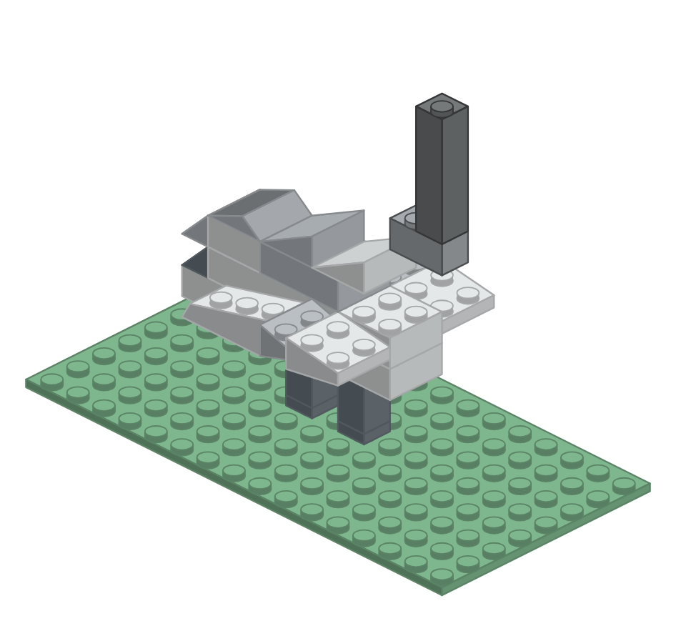
A brick reaching forward past the breast makes a landing for the neck, so the throat stands in front of the chest the way a crane's does. Then one long column, not a stack: the same long-piece-spans, short-piece-joins habit as the legs.
Add these pieces: 1 light gray 1 × 2 brick (seat); 1 light gray 1 × 1 × 4 column
Step 10. Set the head on the column
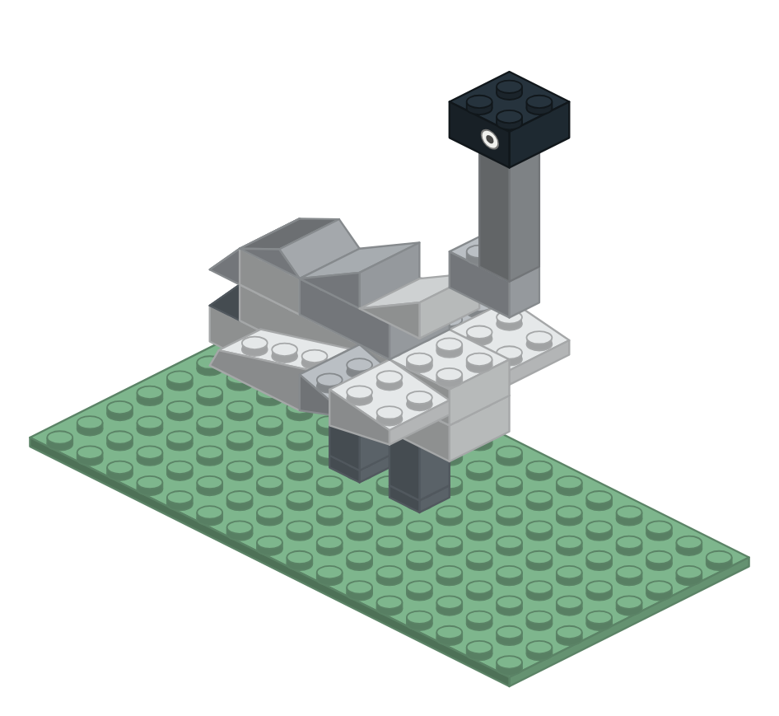
One brick — not two. A white round tile on its side is the eye, and it does more for the bird than any other single piece.
Add these pieces: 1 black 2 × 2 brick; 1 white 1 × 1 round tile
Step 11. Add the beak, then pin it with a plate
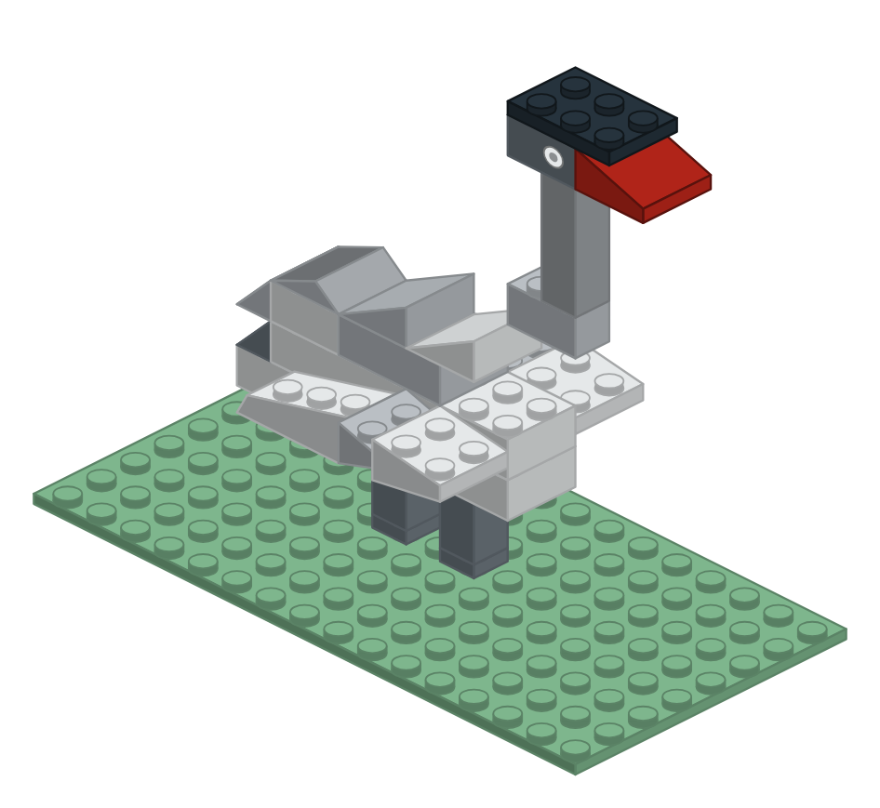
The beak is a slope that stops short of a point, leaving a small upright wall at its tip. A thin plate then runs across the head and forward onto the beak, capping the head and trapping the beak at once — which is what holds a wedge that size on. A beak that did come to a point would have served just as well; none was in the bin. Printing one is a different matter.
Add these pieces: 1 red 2 × 2 slope; 1 black 2 × 3 plate
Step 12. Finish with the golden crown
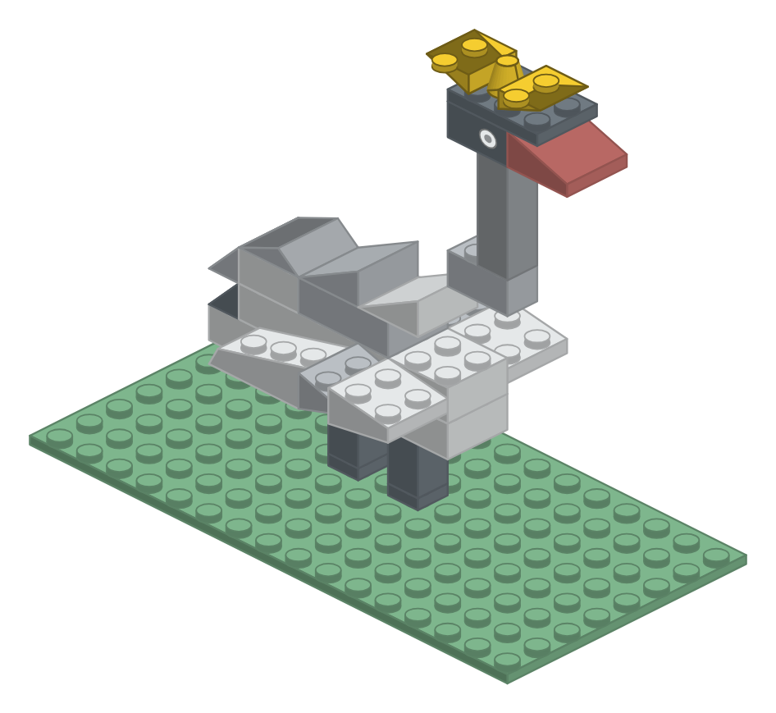
Three pieces, and they splay sideways rather than standing up in a tuft: an inverted slope flaring each way — top full and flat, underside swept away — with a cone between them. A wide golden fan is what names the bird from across a room.
Add these pieces: 2 yellow inverted slopes; 1 yellow cone
When it is standing
Set the finished bird beside the mosaic it came from and compare them: the neck too short, the body too narrow, the crown too tight. Every difference you can name is the next revision. Because the bricks come apart as easily as they go together, changing your mind costs nothing — which is exactly what makes a prototype worth building.

